Software Development Life Cycle (SDLC)
The SDLC is a structured process used to design, develop, test, and deploy high-quality software. Each phase depends on the previous one, ensuring smooth progress and reliable outcomes.
1. Requirements Phase
Purpose:
To understand what the client or user needs.
Importance:
- Defines project scope and goals
- Prevents misunderstanding and rework
- Forms the foundation for all other phases
Output:
Requirement Document, User Stories, Use Cases.

2. Design Phase
Purpose:
To create the blueprint of the software system.
Importance:
- Converts requirements into technical architecture
- Defines system components, interfaces, data design
- Helps developers understand "how" the system will work
Output:
System Design Document (SDD), Architecture Diagrams, Database Design.

3. Implementation (Coding) Phase
Purpose:
To build the actual software product.
Importance:
- Developers write code based on design
- Modules, classes, and APIs are created
- Integrates all components into a working system
Output:
Source Code, Integrated Software Build.

4. Testing Phase
Purpose:
To verify the functionality, quality, and performance of the software.
Importance:
- Detects and fixes bugs
- Ensures reliability, security, and accuracy
- Validates that requirements are met
Output:
Test Reports, QA Sign-off, Bug Logs.

5. Deployment Phase
Purpose:
To release the software into the production environment.
Importance:
- Makes the software available to users
- Establishes final configuration and monitoring
- Marks the official launch of the project
Output:
Live System, Deployment Checklist, User Access Setup.

How These Phases Interconnect (Flow)
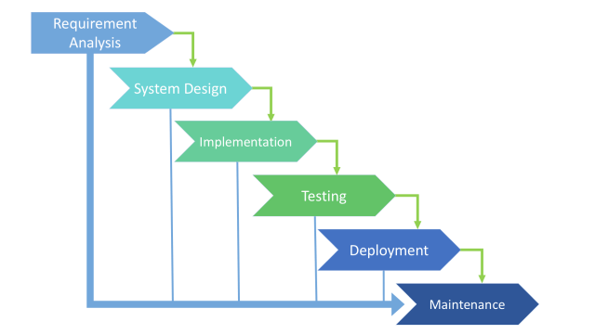Interconnection Explanation:
- Each phase depends on the previous one.
- Requirements guide design.
- Design guides development.
- Development produces software that testing validates.
- Testing ensures software is ready for deployment.
- After deployment, maintenance keeps the system updated and stable.

